Applications and limitations of hemapheresis
A J Silvergleid

Abstract
Hemapheresis is the selective collection of any blood component. With the use of automated equipment, hemapheresis has become practical both for procuring specific components for transfusion and for removing specific components considered pathogenic factors in clinical disease. This review considers all aspects of hemapheresis, including its role in blood component procurement and its potential therapeutic applications. Attention is focused on the clinical indications for the use of apheresis-harvested components, and on the rationale for the effectiveness of therapeutic cytapheresis and plasma exchange.

Apheresis (Hemapheresis, Pheresis) Center

https://www.medicinenet.com/hemapheresis/index.htm
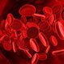
Apheresis (hemapheresis, pheresis) is a process of removing a specific component from the blood of a donor or patient that contains disease-provoking elements. Forms of apheresis include:
- plasmapheresis,
- plasmapheresis,
- leukapheresis or leukopheresis,
- lymphopheresis or lymphapheresis, and
- erythropheresis.
Apheresis is used as a treatment for many diseases and conditions, including:
- myasthenia gravis,
- lupus,
- severe rheumatoid arthritis,
- polymysositis,
- vacuities, and more.

What Is Hemapheresis? (with pictures)

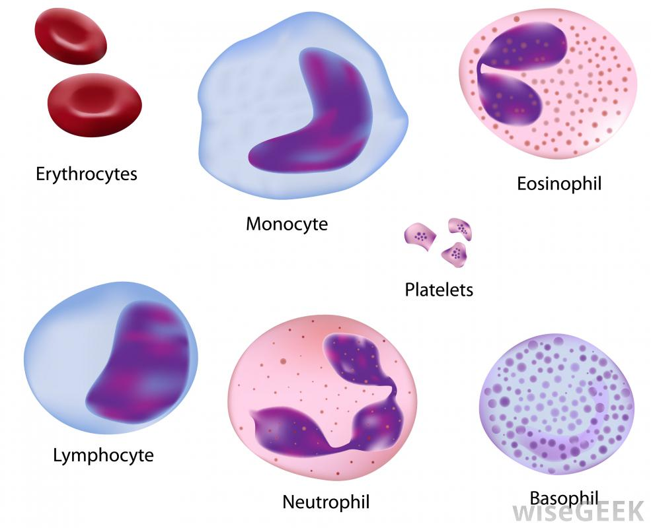Hemapheresis can target specific types of white blood cells for removal.
Blood is made up of several components, and hemapheresis is the process of separating out one component from the blood and infusing the remainder back into the body. Particular cells, or particular biological molecules, can be the targets for this removal technique. Hemapheresis is also known as apheresis, pheresis or therapeutic hemapheresis.
Occasionally, the composition of the blood in the body can be unbalanced for health, and altering the levels of some components can help ease disease. Major cells found in blood include red blood cells and white blood cells. The white blood cell group includes five separate types of cells: the lymphocytes, monocytes, neutrophils, basophils and eosinophils. Platelets, which are fragments of cells, also circulate in the blood. The liquid in which these cells move around is called plasma.

Along with cells, blood carries biologically active molecules. Some examples are cholesterol molecules, which can affect circulatory health if present in certain concentration ratios. Medical professionals can use the technique of hemapheresis to remove unwanted cells or molecules from the blood, thereby reducing the risk to the patient's health.

Hemapheresis requires the patient to have a needle inserted in the body, out of which the blood can flow. This needle is attached to a machine that the blood runs through and that removes the unwanted component. Another needle system from the machine is also placed into the body for the blood to re-enter the circulatory system. Typically, the nurse puts the outflow needle in one arm and the inflow needle in the other.

Blood contains many nutrients that the body needs for efficient functioning, such as calcium, so this procedure can have temporary effects. Examples of side effects include becoming cold, suffering cramps in the legs or numbness in the extremities. On rare occasions, the patient can feel dizzy, and some might feel unusually tired.

One example of the medically beneficial use of hemapheresis is the removal of plasma from the blood to help treat lupus or rheumatoid arthritis. In this case, new plasma is introduced instead of the old plasma. The new plasma contains none of the substances present in the patient's own plasma that can cause the autoimmune disease symptoms.

Red blood cell removal and replacement can help people whose own red blood cells do not work correctly, as in the case of sickle cell disease. Excess levels of white blood cells can occur in illnesses such as leukemia, and reducing the amount of cells can avert more health issues. Hemapheresis techniques also can be used to separate out white blood cells so they can be treated with ultraviolet light and returned to the patient's bloodstream. This treatment can help reduce unwanted immune reactions to organ transplants or other, similar conditions.
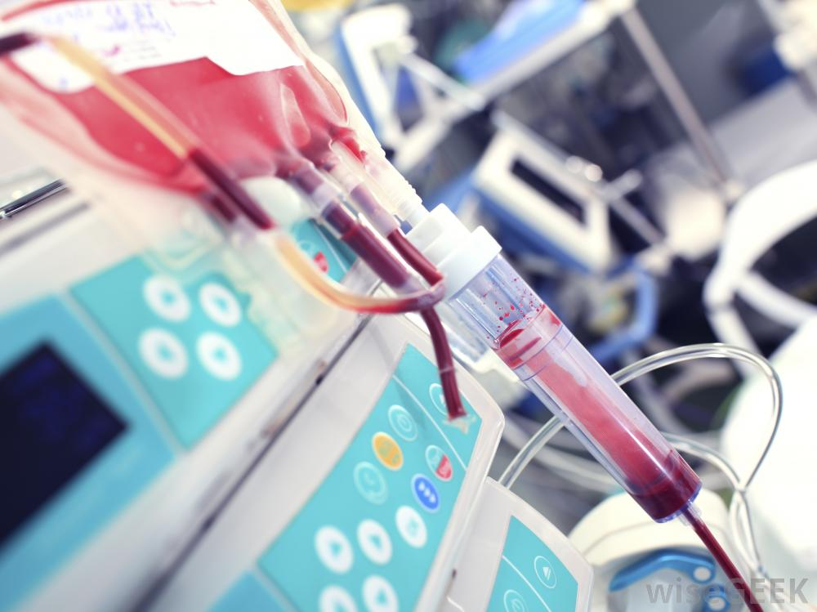Blood is infused back into the body after hemapheresis.
Abnormally high amounts of platelets in blood can increase the risk of cardiovascular problems such as stroke. Hemapheresis can sift out the excess platelets to reduce the risk. Another possible use of the technique is to harvest stem cells in the blood, which can repopulate affected areas of the body, in patients who are undergoing radiation therapy.

