Plasmapheresis: Side effects and how it works
https://www.medicalnewstoday.com/articles/321451
Plasmapheresis is a medical procedure designed to remove some plasma from the blood. During a plasma exchange, unhealthy plasma is swapped for healthy plasma or a plasma substitute, before the blood is returned to the body.
The blood vessels contain plasma. It is a fluid made up of blood cells, platelets, and essential nutrients.
During plasmapheresis, blood is removed and separated into these parts by a machine.
Plasmapheresis can also refer to when plasma is removed from the body to be donated.

What is plasmapheresis?
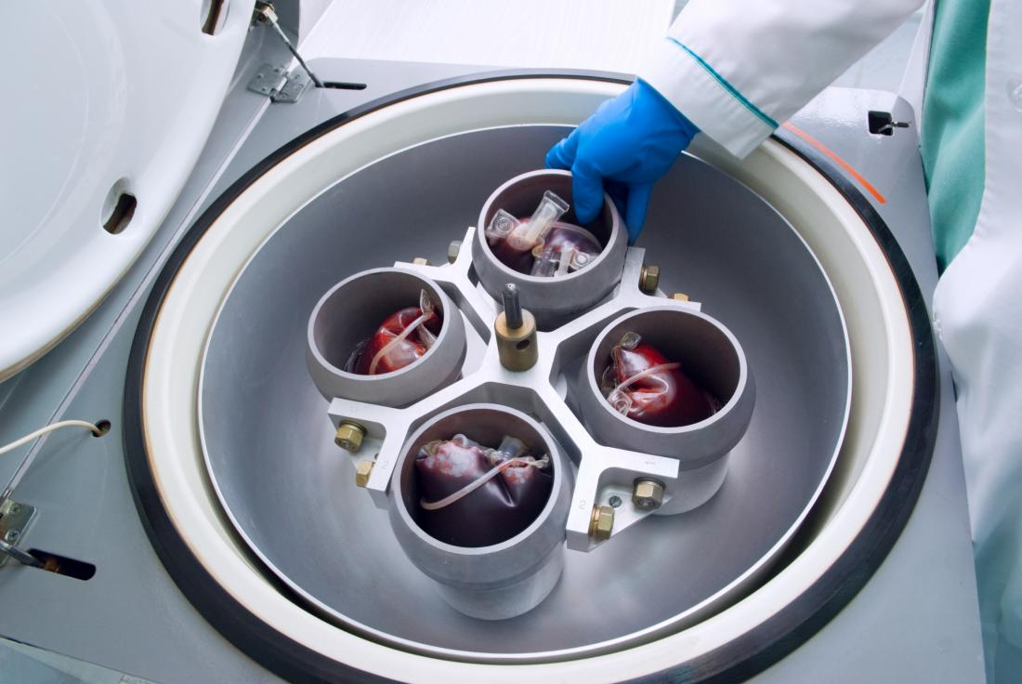Share on PinterestCentrifugation spins the blood for plasmapheresis.
Pheresis, or apheresis, describes any process that removes the blood, filters and retains elements of it, then returns the blood to the body. Platelets, red blood cells, white blood cells, or plasma may be separated.
The procedure is performed using a machine that removes small amounts of blood at a time.
There are two ways to separate the components of blood:
- Centrifugation. This process spins the blood, which divides it according to the density of the parts.
- Filtration. This involves passing the blood through a filter to separate plasma.
During a plasma exchange, the machine will dispose of unhealthy plasma and replace it with healthy plasma from a donor. Unhealthy plasma can also be replaced with saline, albumin, or a combination of the two.

Why undergo a plasma exchange?
A plasma exchange can help to treat a range of medical conditions, including:
- Brain and nervous system conditions, such as acute Guillain–Barré syndrome.
- Blood disorders, such as thrombotic thrombocytopenic purpura, a rare disorder that causes blood clots.
- Some kidney conditions, such as Goodpasture syndrome, a disease that causes antibodies to attack the kidneys and lungs.
- Hyperviscosity syndromes, including myeloma. These conditions cause the blood to thicken, which can lead to organ damage or a stroke.

Benefits
A plasma exchange can help to alleviate symptoms of the conditions above by removing harmful substances from the blood.
If a person has an autoimmune condition, a plasma exchange may also prevent the body from producing more harmful antibodies.
The procedure is usually one element of a treatment plan, which may include chemotherapy. Repeated plasma exchanges may be necessary.

How to prepare
A person can eat and drink normally before and even during plasmapheresis. Wearing loose clothing can help a person to stay comfortable. Use the bathroom before the process begins.
An individual will first undergo tests to determine:
- blood pressure
- pulse
- temperature
- oxygen levels
The results will help a doctor to set up the machine and monitor any changes that occur during the procedure.

